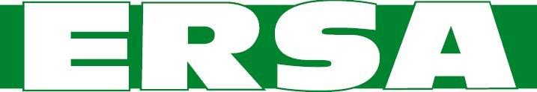
Elizabethtown Regional Sewer Authority
Board Meeting Agenda
January 10, 2023, 6:30 PM
_____________________________________________
- Call to Order/Pledge of Allegiance
- Public Comment
- Approval of the December 13, 2022 Meeting Minutes
- Reorganization of the Board

- General Business
A. Approve or reject CDM Smith’s rate schedule for 2023
B. Review pay application no. 3 for Anrich Inc. plus change order information
C. Personnel Discussion

5. Reports
- Engineer
- Treasurer

6. Adjourn

