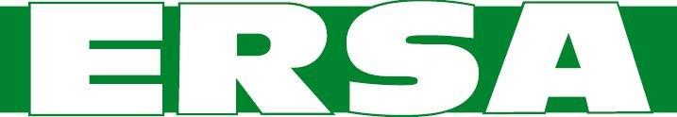
Elizabethtown Regional Sewer Authority
Board Meeting Agenda
June 14, 2022, 6:30 PM
_____________________________________________
- Call to Order/Pledge of Allegiance
- Public Comment
- Approval of the May 10, 2022 Meeting Minutes

4. General Business
A. Status of the Hershey Developers Tact (Hoffer)
B. Results of the Miller Road kick off meeting
C. Requests from Maytown Avenue residents
D. Amend Sewer Line Specs – Laterals connected to houses
E. Waste Management private line concerns
F. Tiny Homes Estates – On lot sewer overflow
G. Capacity Reservation Policy

5. Reports
- Engineer
- Treasurer

6. Adjourn

